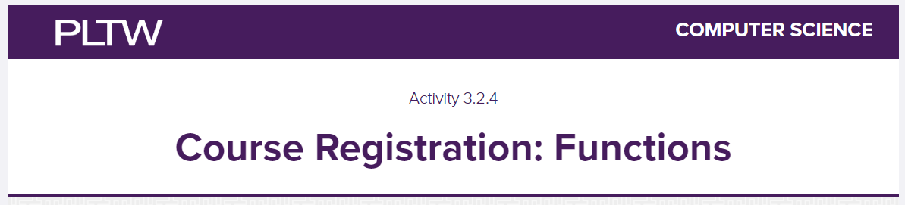

Prior to Number 1:

Download the course registration software that we will edit by clicking on the “hamburger” at the top left of the Trinket on mypltw 3.2.4.

Click Download

Go to your File Explorer

Go to your Downloads Folder

Left click then right click on the Zipped Folder

Click Send To

Click Browse

Find you CSE Folder on your Desktop

Find your Unit 3 Folder

Find your 3.2 Folder inside of your Unit 3 Folder

(if you dont have these created already, why?....really why? Weve been doing this since the beginning of January…..CREATE THEM NOW!!!!!)

Click Select Folder

Open Visual Studio Code

Click File>Open Folder>3.2

(because we will have multiple files talking to each other they MUST, MUST , MUST be in the same folder AND….AND unzipped) Make that happen.

3) Fill in the table as seen in my pltw’s #3

| Formatting Character | What is does |
| --- | --- |
| “\n” | Creates a new line inside the print string output. |
| “\t” | Creates a tab inside the print string output. |
| “\” | Continue a string on a new line without splitting the output. |

Use your own words here and paraphrase. Dont copy and paste.

4) Give me a screenshot of the TODO code:

Two more courses(doesnt matter to me what you call them):

|  |
| --- |

3rd Student: This student should be you! Put your name in! Fill in your 2nd semester schedule!

|  |
| --- |

Adding test students to the list:

|  |
| --- |

Printing the student list (use one or more of the formatting tips from #3)

|  |
| --- |

5) give me a screenshot of your output screen/bottom screen in VSCode

|  |
| --- |